<!DOCTYPE html>

<body>

<video src="https://img3.tukuppt.com/video_show/2418175/00/02/49/5b7147f3a6ac4.mp4" controls></video>

<video src="ee.mp4" controls></video>

</body>

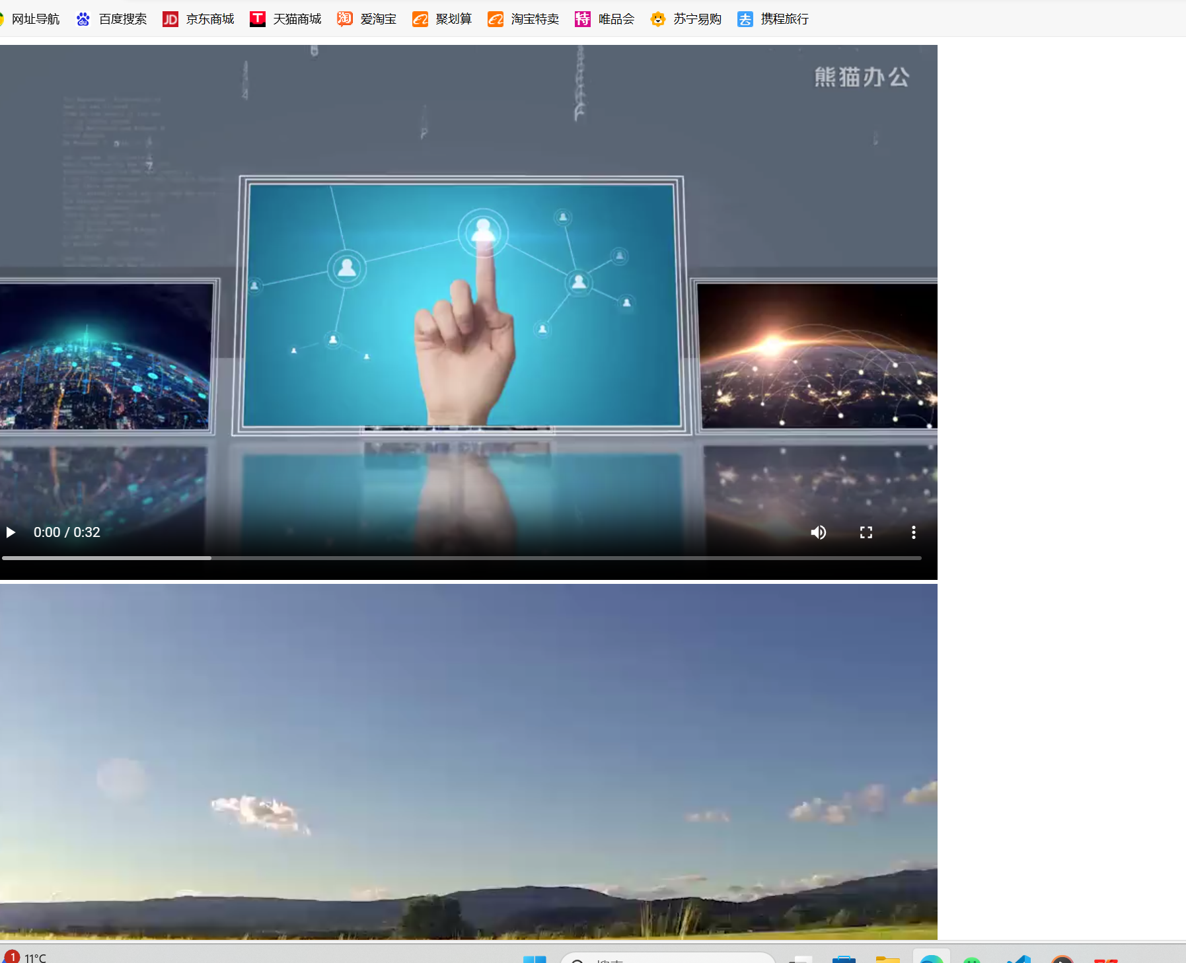

<!DOCTYPE html>

<body>

<audio src="music.mp3" controls></audio>

<br>

<audio src="https://dl.stream.qqmusic.qq.com/C400000BS56a11a4DG.m4a?guid=560115575&vkey=9AC18B0559701D14100873DD30EF4527280ADE9F2AB634A742F295FED9949A7BCC186901F62FF214D291E48287244A3B921E5A1662BBA6E2&uin=1927519179&fromtag=120032" controls></audio>

<br>

<audio controls>

<source src="SEVENTEEN - Monster.ogg" type="audio/ogg" />

</audio>

</body>

